CSA1304 - THEORY OF COMPUTATION
LABORATORY EXPERIMENTS
Name: P. Pranesh
Reg No: 192311003
3. Write a C program to check whether a given string belongs to the language defined by a Context Free Grammar (CFG)
S → 0A1, A → 0A | 1A | ε
Program Code
#include <stdio.h>
#include <string.h>
int main()
{
char str[100];
int i, valid = 1;
int len;
printf("Enter a string: ");
scanf("%99s", str);
len = strlen(str);
if (len < 2 || str[0] != '0' || str[len - 1] != '1')
valid = 0;
for (i = 0; i < len; i++)
{
if (str[i] != '0' && str[i] != '1')
{
valid = 0;
break;
}
}
if (valid)
printf("String belongs to the CFG language.\\n");
else
printf("String does not belong to the CFG language.\\n");
return 0;
}
Output
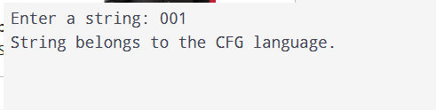.
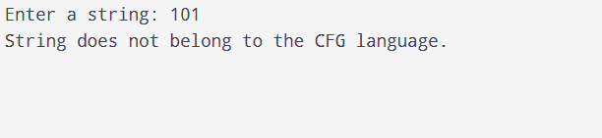

4. Write a C program to check whether a given string belongs to the language defined by a Context Free Grammar (CFG)
S → 0S0 | 1S1 | 0 | 1 | ε

Program Code
#include <stdio.h>
#include <string.h>
int main()
{
char str[100];
int i, j, valid = 1;
int len;
printf("Enter a binary string (use # for epsilon): ");
scanf("%99s", str);
if (str[0] == '#' && str[1] == '\0')
len = 0;
else
len = strlen(str);
if (len == 0)
valid = 1;
else
{
for (i = 0, j = len - 1; i < j; i++, j--)
{
if (str[i] != str[j])
{
valid = 0;
break;
}
}
if (valid && !(len >= 1 && (str[0] == '0' || str[0] == '1')))
valid = 0;
for (i = 0; i < len; i++)
{
if (str[i] != '0' && str[i] != '1')
{
valid = 0;
break;
}
}
}
if (valid)
printf("String belongs to the CFG language");
else
printf("String does not belong to the CFG language");
return 0;
}

Output
